**PUBLIC DEBATE ON MODEL VILLAGES AND PEACE BUILDING IN KIGALI CITY**

On 13th October 2023, SYTRIECI RWANDA participated in a public debate on model villages and peace building in Kigali city which was hosted by FES Rwanda and IRDP (institute of research and dialogue for peace). The participants shared perspectives on the IDP model village livelihood for decent housing, peace and social cohesion and also about the new initiatives to promote decent and affordable housing.

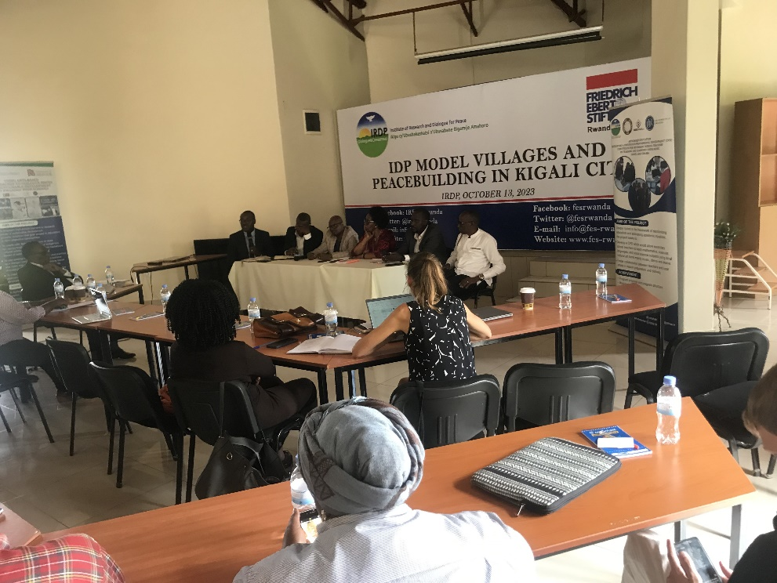

***Government officials and private sector representatives headed the public debate***

Different representatives of the organizations and the government participated in the debate and also presented the progress and challenges of the promotion of model villages in Kigali and also some rural areas as well.

Other participants also had time to ask questions to the members of the panel and also made different suggestion about the journey of promoting decent and affordable housing in Rwanda. The participants also suggested the topic that should be discussed in the next public debate since it is going to be re-occurring every month.

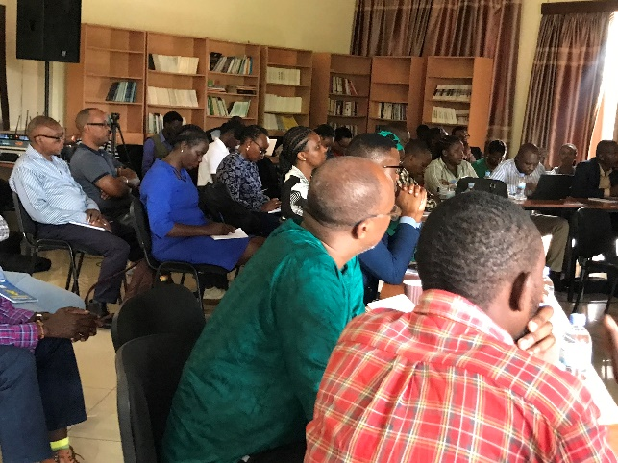 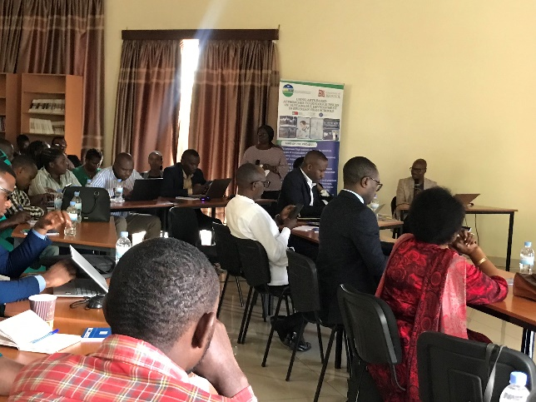

***Organizations that advocate for human rights and media practitioners participated in the debate***