**INTRODUCTION OF IDWF TO DOMESTIC WORKERS IN SYTRIECI RWANDA**

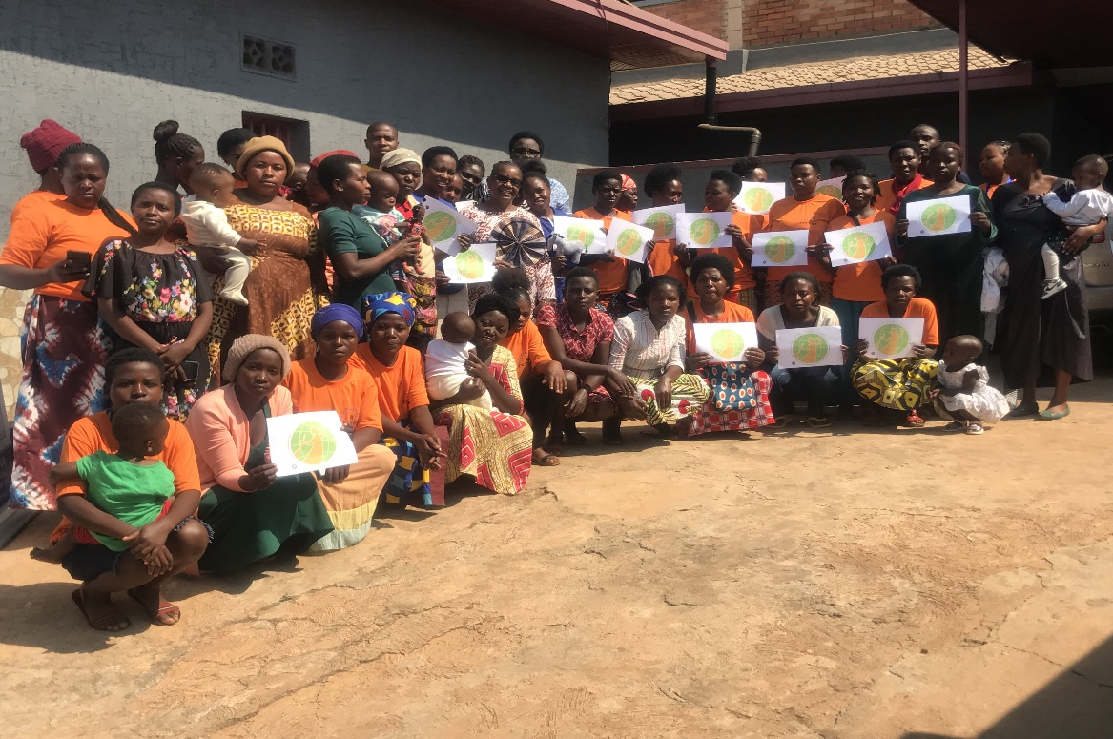

On 21st July 2023, SYTRIECI RWANDA received a visit from IDWF (international domestic workers federation) regarding the recent partnership between IDWF and SYTRIECI. The IDWF representative, Mrs. Vicky Kanyoka, met some of the domestic workers in Sytrieci Rwanda and explained to them what the project is about and how they will benefit from it.

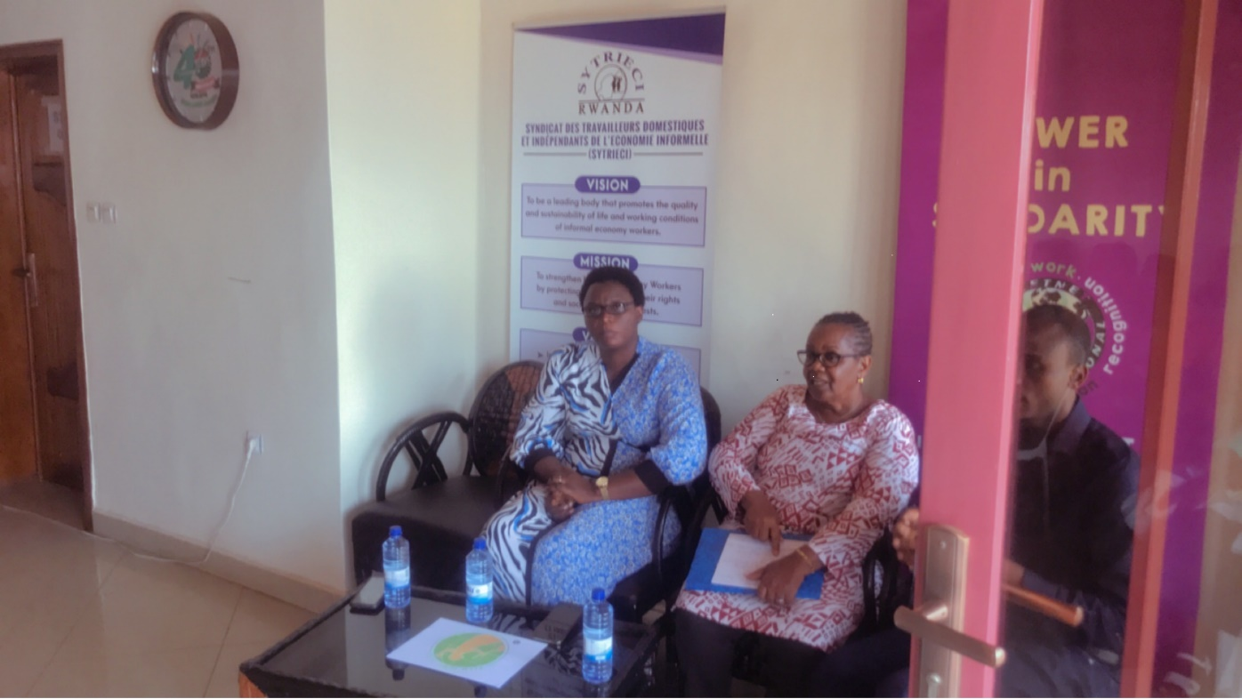

The invited members expressed their gratitude to IDWF and SYTRICI and to the project they initiated to help them regain their rights and develop themselves. Mrs. Vicky Kanyoka encouraged the domestic workers to enlarge their horizons and find extra source of income. She also encouraged them to advocate for the increase of their minimum wage and for the employees’ rights that they don’t often receive.

